__________________________________________________________________

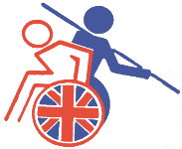
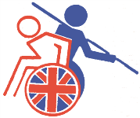
British Wheelchair Athletics
Association

BWAA Training Entry form Date:

Name: Venue: Stoke Mandeville Stadium,

Address: Guttmann Road, Stoke Mandeville,

Bucks. HP21 9PP

E-Mail address:

Tel:

Mob:

Athlete Junior | B | Athlete Senior |  | SDMS ID | Class. |  | Coach |  | Escort

Hotel Accommodation:  Olympic Lodge, Aylesbury | Friday | Saturday | Sunday
Twin Room : £ 37.50 |  |  |  | £
Dormitory : £ 12.50 If available |  |  |  | £
Breakfast : £ 4.50 |  |  |  | £
Dinner : £ 6-50 |  |  |  | £
Entry Fee for the Weekend ( Athletes ) |  |  |  | £ 5 . 00
Total Amount Payable……. |  |  |  | £

If sharing, whom with:

Please return completed form by Email or Post with payment (Cheques payable to BWAA). Do not send Cash.

To: Barbara Hoole. 30 Grape Lane. Croston. PR26 9HB Lancs.
Tel: 07505107106

Email: barbarahoole@hotmail.com

TO BE RETURNED NO LATER THAN : 25th October 2017

CHARITY No. 1149300

